WEDE6010 PORTFOLIO OF EVIDENCE

Duran Moodley 13016335

Assignment 2

Contents

Specifications 2

Flow Chart 4

UML Diagrams 13

Use Case Diagram 13

Sequence Diagram 14

Database Design 15

ERD 15

Table Structure / Sample Data 15

Screenshots/Test Data 17

Validation 24

Help File 25

Lecturer Feedback & Corrections 25

Challenges 25

Improvements made 25

Additional Documentation Linking the page 26

# 

# Specifications

**Startup Page**

This page introduces the website to the user. This contains information about the eShop and text to entice the user to shop.

**Login Page**

This pages accepts the username, password and email address. Clicking on the login button will first validate all input and then perform a search of the user’s credentials in the user’s database table. Once it’s been found, the user’s details will be displayed on the screen, together with a button prompting the user to view items in the shop. An error message will be displayed if the credentials are not found. A link to the registration page will be shown.

**Registration Page**

This page will allow any user to register onto the site. They will need to enter in their username, password and email address. After all fields have been validated, the credentials will be sent to the database. Error message will be displayed if the fields are not entered in correctly.

**My Shop Page**

After the user has successfully logged on, the items page will be displayed consisting of a table and details about the items in the shop. This will contain: the item picture, item id number, item description, item price, item cost price and an add to cart button. Clicking on the add to cart button will add that item to the users cart in an array. This array will continually be updated as the user makes changes.

**Shopping Cart Page**

This shows the user all the items that they have selected. This page can also remove and increment the amount purchased for that item. In addition, this page also allows the user to check out once he/she is satisfied with their cart. This page will send the order details to the orders table.

**Admin Login Page**

Allows an administrator to log on to the system. An administrator user name and password has already been set. The administrator needs to enter those exact credentials in order to get administrative privilege.

**Admin Page**

This page allows the administrator to add, delete and update a particular item. Changes that are made here will affect the items table in the database.

**Add Item Page**

An item can be added to the items table in the database. Only the administrator can do this action. He/She will need to enter in the relevant item details.

**Edit Item Page**

After selecting the item to edit, this page will show all details of that particular item. The administrator can now change any details they wish.



# Flow Chart

















# UML Diagrams

In replacement of a class diagram I have incorporated a use case diagram as I feel it is more focused and makes better logical sense.

## Use Case Diagram





## Sequence Diagram



# Database Design

## ERD



## Table Structure / Sample Data

**Tbl_customer**

|  |  |  |  |  |
| --- | --- | --- | --- | --- |
| CustId[PK] | custName | custSurname | custEmail | Password |
| 1 | Sarina | Till | sarinatill@vc.co.za | 46b7e6d3287356c1777cdc382240b5ec |
| 2 | Maggaret | Thomas | maggaretthomas56@gmail.com | 2811de7aaf9aafda9f071b23e99f08d7 |
| 3 | Mtho | Kobone | romeo89@gmail.com | 05bcc6f1b7a0a4a8b6620f26f1dfd581 |
| 4 | Rajesh | Chanderman | rajchanderman00@gmail.com | d14dad027e25674e03ec4a4a75e41265 |
| 5 | Andrea | Mesarits | andmesaritis34@gmail.com | 91eb0cbb6340e71f7f53e8e4d3711282 |

**Tbl_items**

|  |  |  |  |  |
| --- | --- | --- | --- | --- |
| ItemId[PK] | Description | Cost Price | Quantity | SellPrice |
| 1001 | a stylish phone cover that can protect your phone | 150 | 100 | 250 |
| 1002 | laptob bag that can give your laptop the comfort i | 400 | 200 | 500 |
| 1003 | 20 gb flash drive that can plug into any device | 100 | 200 | 120 |
| 1004 | PHP coding book that gives php guidelines | 1000 | 50 | 2000 |
| 1005 | Flat screen tv with usb connection ports | 15000 | 20 | 20000 |

**Tbl_order**

|  |  |  |
| --- | --- | --- |
| orderId[PK] | ItemId[PK] | CustId[PK] |
| 4n937faj7ef8ht49e2a3246jv2 | 1001 | 1 |
| 4n937faj7ef8ht49e2a3246jv2 | 1002 | 1 |
| 4n937faj7ef8ht49e2a3246jv2 | 1004 | 1 |
| 4n937faj7ef8ht49e2a3246jv2 | 1005 | 1 |
| 4n937faj7ef8ht49e2a3246jv2 | 1007 | 1 |

# Screenshots/Test Data

**Startup Page**

*This page welcomes the user to the eShop. In addition, the user can click on any button depending on their desired action. (Shop, Logon, Register, Admin)*

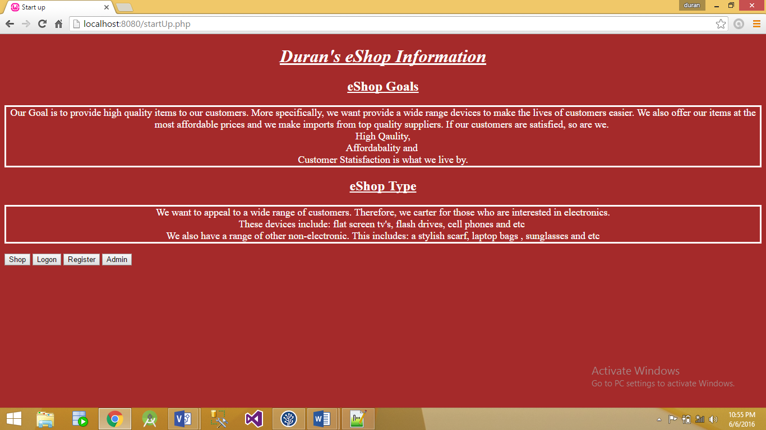

**My Shop Page**

*The user can select any item to add to their cart by simply clicking on the add item link. The shopping cart link will redirect them to view the contents of their cart. Home will display the start up page.*

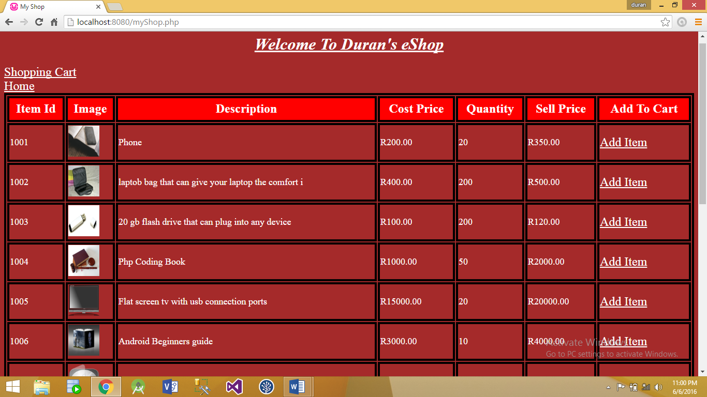

**Shopping** **Cart**

*This displays all items that the user has selected in the My Shop page. Here the user can select additional actions.*

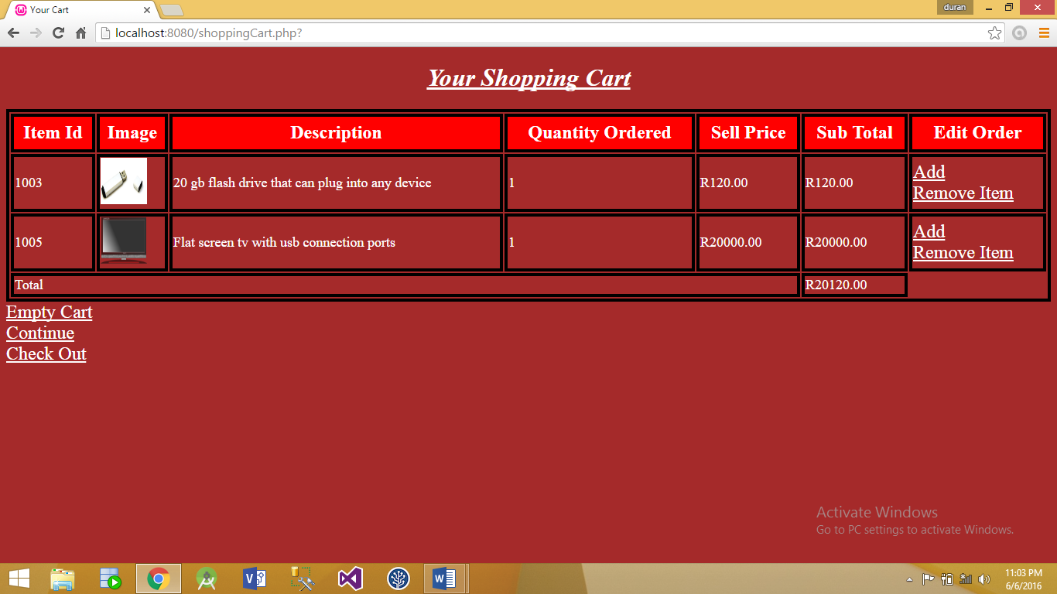

**Shopping cart – Remove Item & Add clicked**

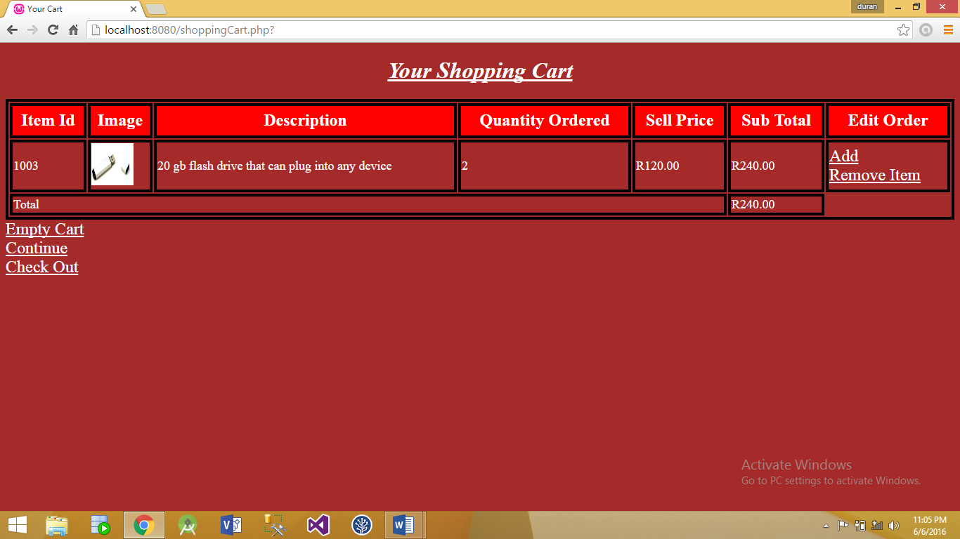*Clicking the add button will increment the quantity order field. Clicking remove will delete that item from the user cart.*

**Shopping cart – Empty cart Clicked**

*If the empty cart is clicked, all items in the cart will be deleted.*

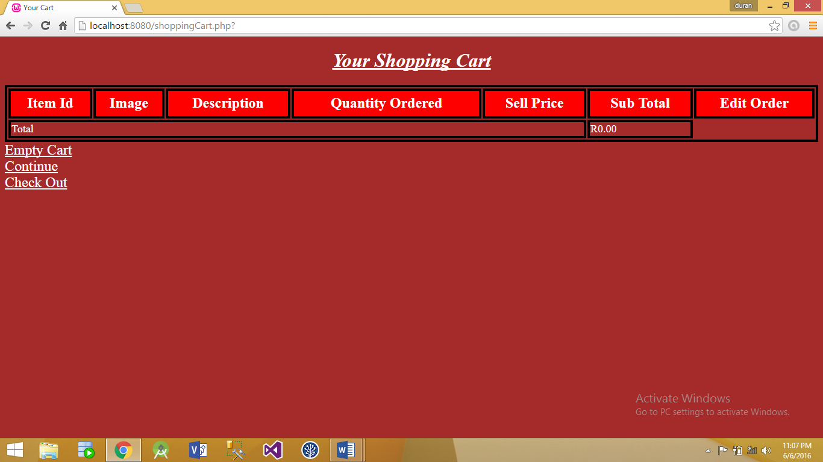

**Shopping Cart – Checkout Clicked**

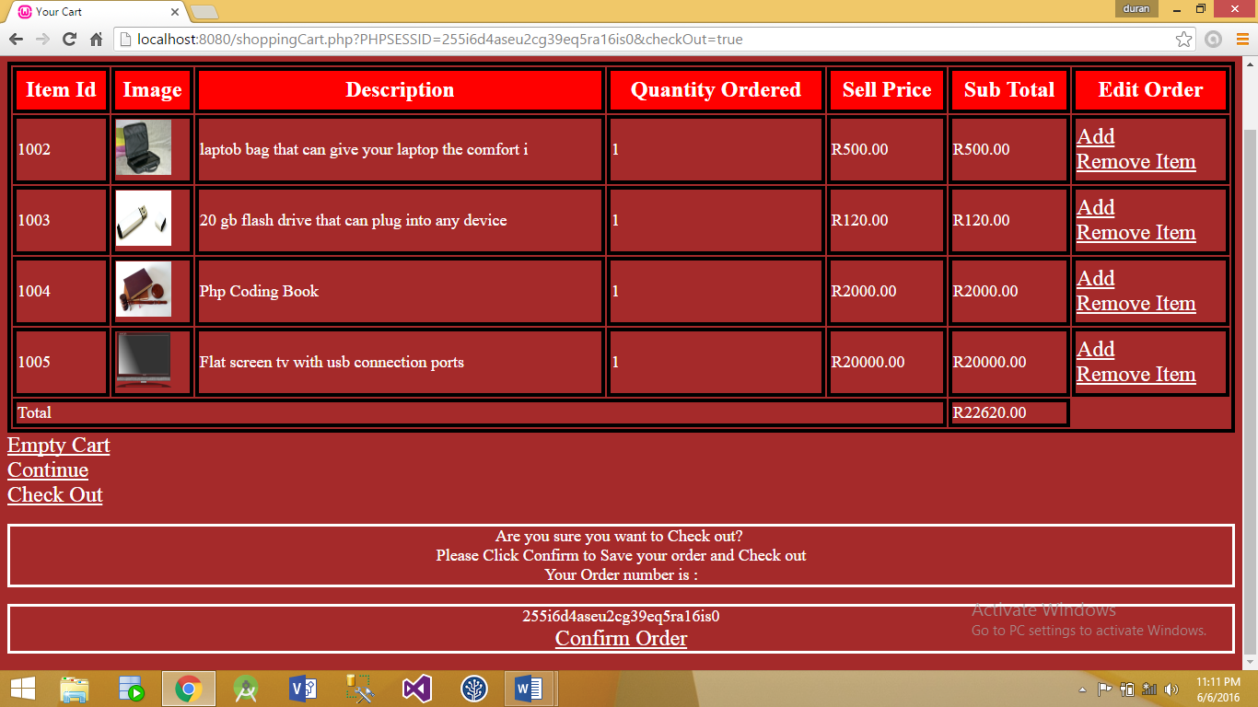*The system will first check if the user is already logged on. If he/she is, they will receive a confirmation message and will receive an order id. Clicking confirm will send that order to the database table.*

**Shopping Cart- Confirm link clicked**

*Logout link is displayed. Clicking this will log the user out.*

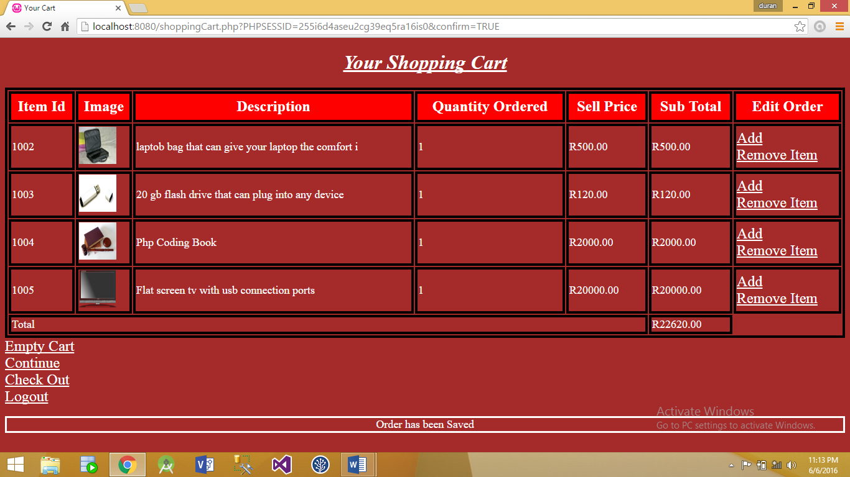

**Login Page**

*The user can enter in their credentials to log in.*

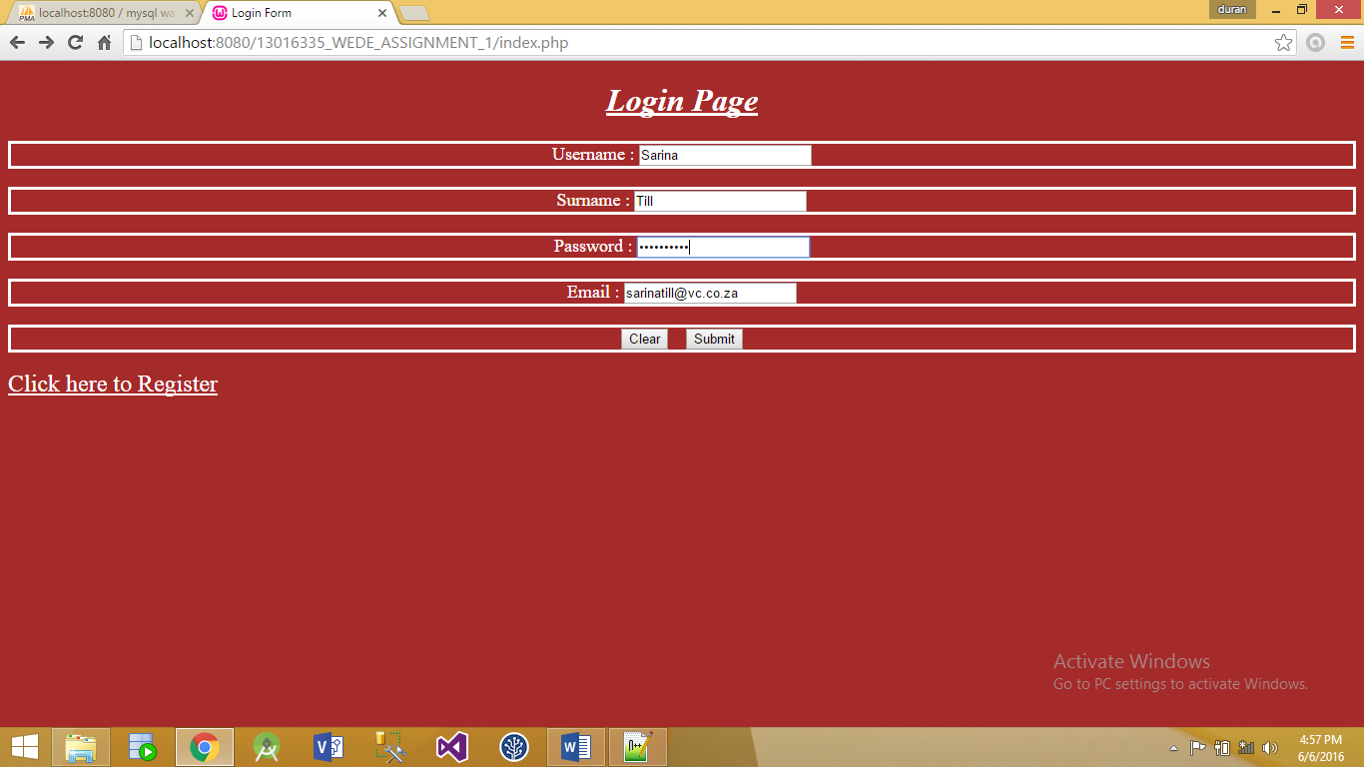

**Login Page**

*User has enter in the correct credentials and can now view the item details by clicking the show item button.*

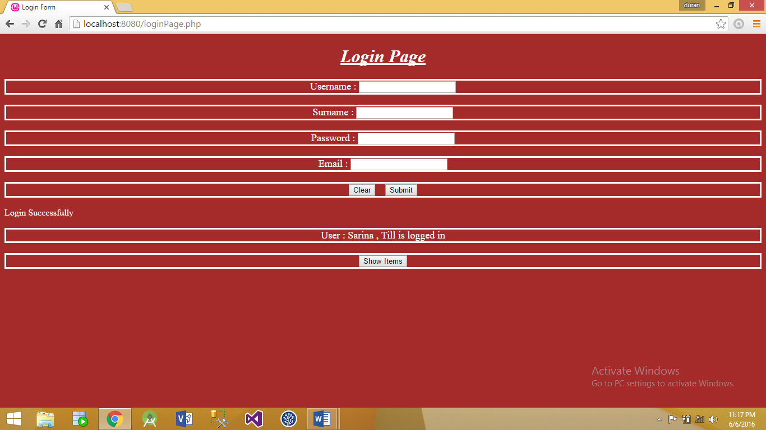

**Registration Page**

*User needs to enter in the required details into the text fields.*

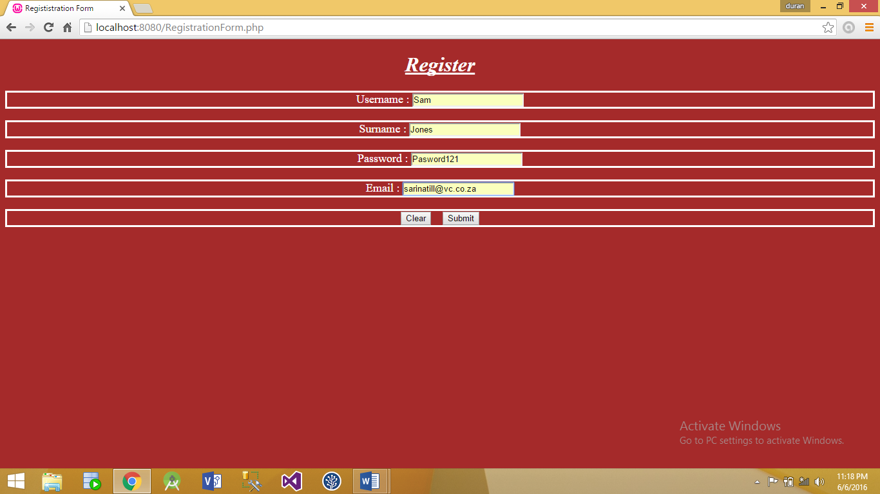

**Registration Page – User added**

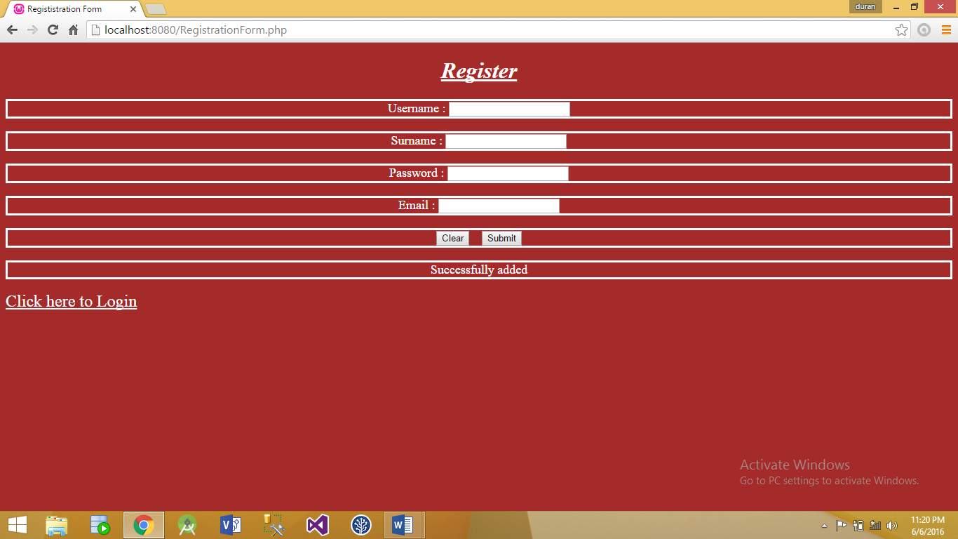*User has now been added. Confirmation message displayed*

**Admin Login**

*Administrator can enter in their credentials. Submit will verify it. If Successful, administrator will be taken to the Admin page.*

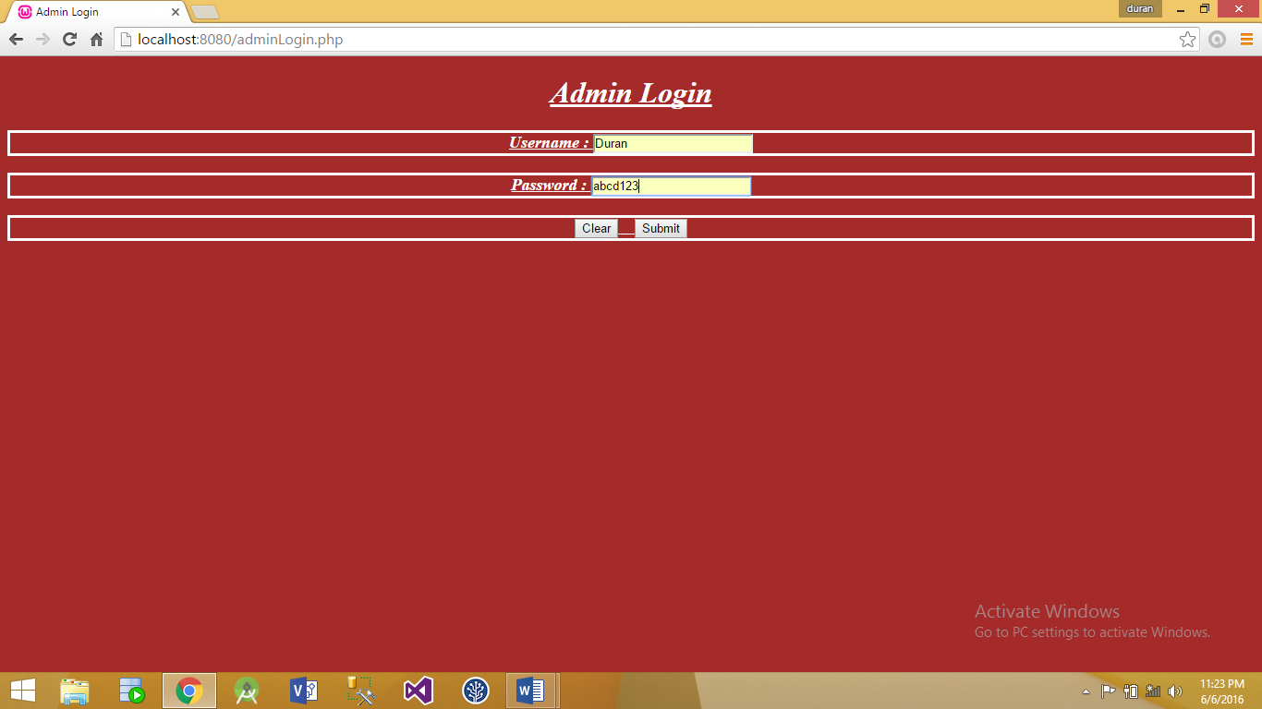

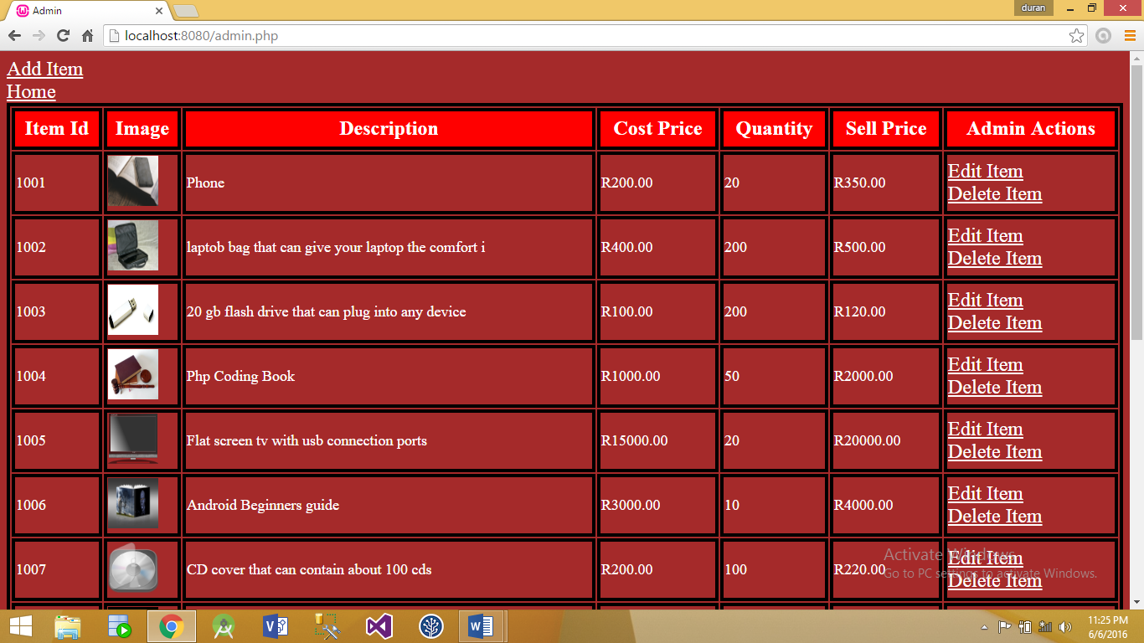**Admin Page**

*This page will allow the administrator to perform a wide range of operations.*

**Admin Page – Delete Item Clicked**

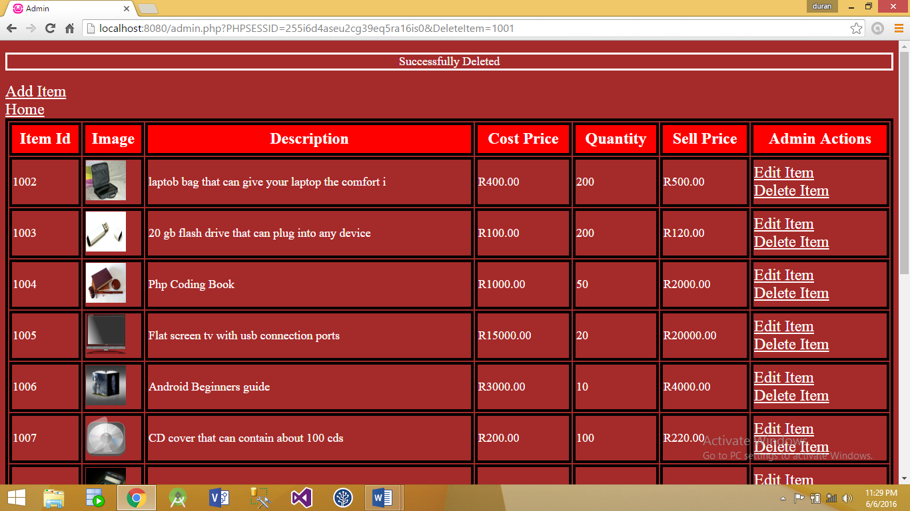*Item 1001 has now been deleted. Confirmation message is shown on the top of the page.*

**Add Item Page**

*The administrator needs to enter in the necessary fields. Clicking submit will add this item.*

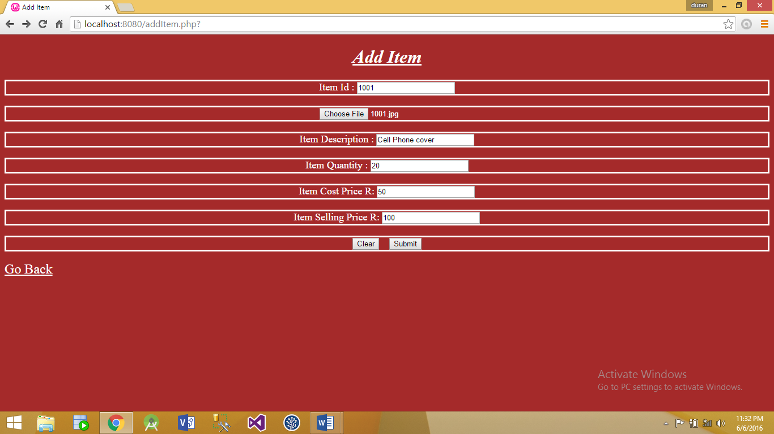

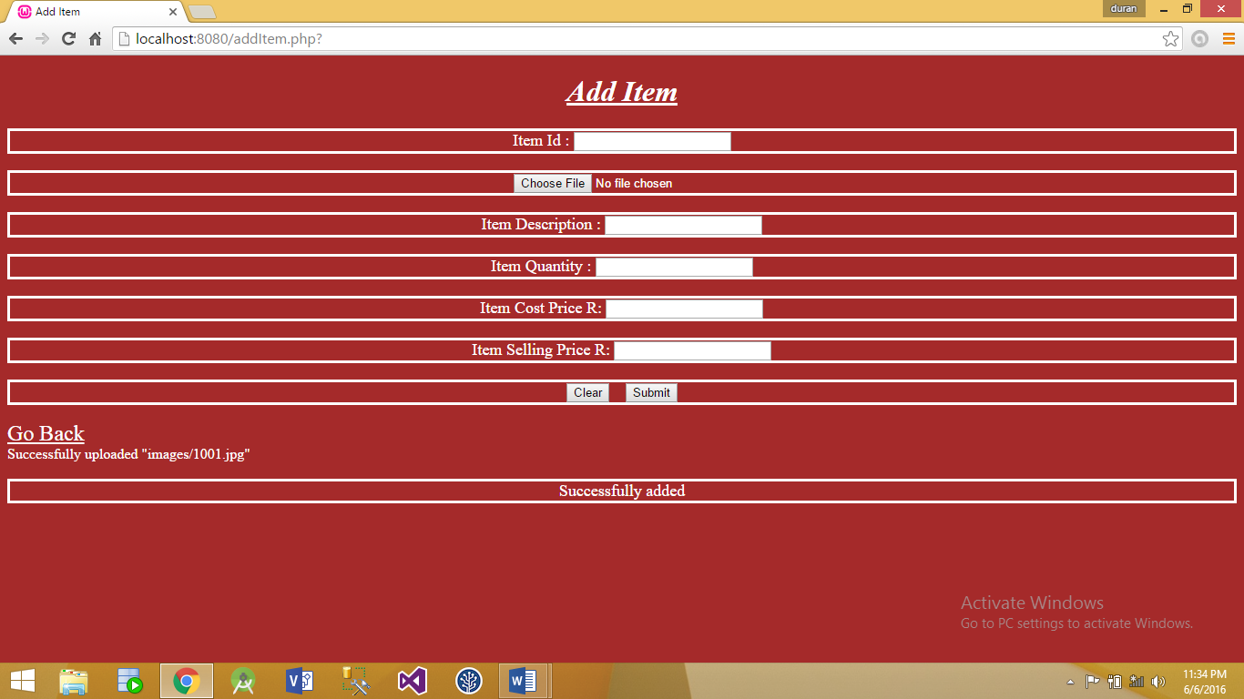**Add Item- Confirmation message**

**Edit Item Page**

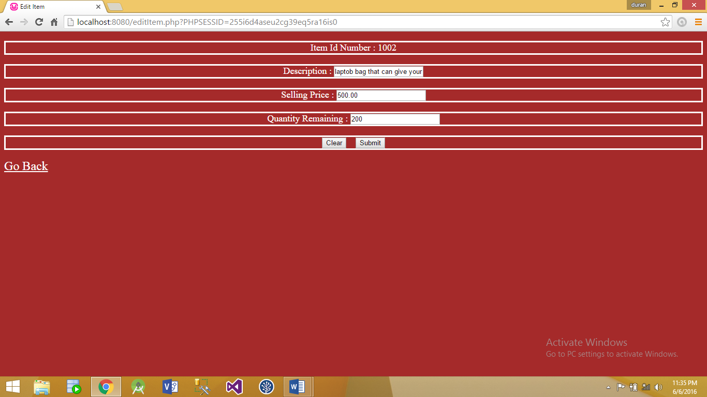*After selecting the item in the Admin Page, the item details will be shown in the text boxes. A change can be made in any field.*

**Edit Page- Submit clicked**

*Quantity has been changed from 200 to 150. Confirmation message is shown.*

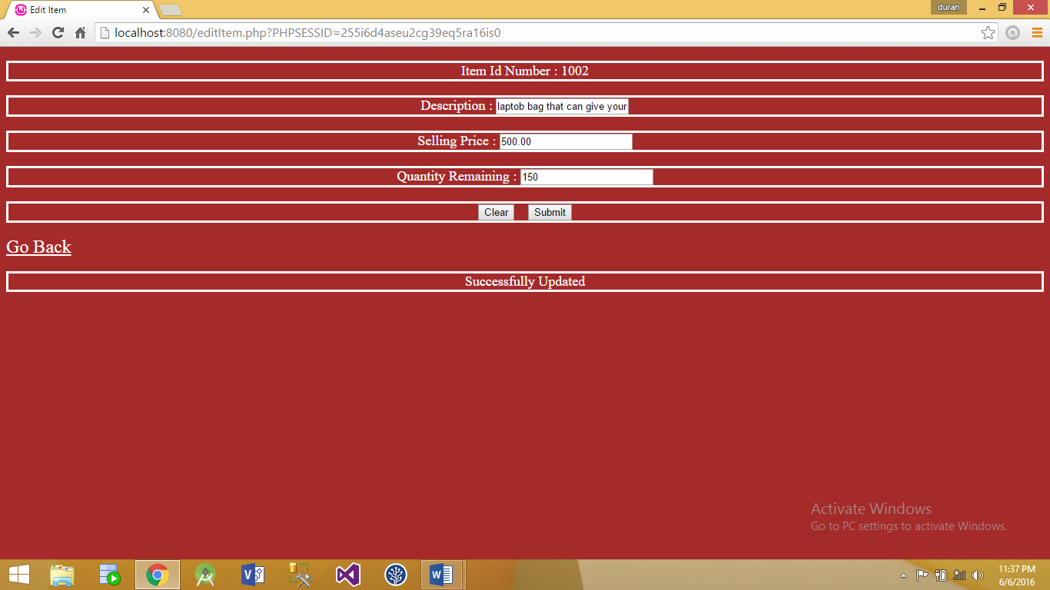

# Validation

Please refer to assignment 1 POE documentation. The same validation techniques and messages are used in assignment 2.

# Help File

On the start page, you can select any of the 4 options presented.

Selecting the Shop button will allow you to select items to add to your cart. The My Shop page will be displaying giving you details about all items in the shop. On this page you can view your cart by clicking the Shopping cart link. This will redirect you to another page with additional options to select. You can continue shopping which will take you back to the My Shop page. You can increment the quantity of a single item in your cart by clicking the add link. You may also remove an item or empty your cart completely. The checkout button will allow you to confirm your order. However, you first need to logon before you can complete this action.

The logon page is fairly simple. Please make sure all fields are entered in correctly. If your credentials are not found, please re-register.

The registration page has a similar process to that of the logon page. Please make sure you enter in a password that contains a wide range of characters and numbers.

# Lecturer Feedback & Corrections

|  |  |
| --- | --- |
| Feedback | Corrections Made |
| Data types of primary and foreign keys must be the same | Data types have been changed accordingly |
| Remove the extra step when the administrator has to click on the edit item link and then click the Go to Edit page link | The extra step has been removed. Once the user has clicked on the edit item link he/she is redirected to the edit page. |

## Challenges

* There we a number of challenges that I experienced. One of those was using the GET and POST responses. At first I was having trouble at triggering the methods to add, remove or delete an item from the user cart. Using the GET technique, I was able to put forward a get response that would trigger the method to fire. The POST response can be used for button clicks which was greatly used.
* Serialization was another important concept that needed to be implemented. This concept preserves the state of an object. Once it’s been serialized, I can store it in a session variable and un-serialize it. This will allow me to use all the data that was previously stored in that object.
* In order to properly serialize, I had to create a class that contained methods and variables. Using a class allowed me to reuse code and save time. This taught me the benefits and advantages of employing OOP into programming.

# Improvements made

* All password fields input type has been changed to “password”. This will hide the password value when the user is entering it in the field.
* Used the predefined methods : _construct , _destruct and _wakeup functions
* Destroyed the session after the user has logged out

# Additional Documentation Linking the page

<http://localhost:8080/startUp.php>